

**Harding Memorial Primary School**

**Anti – Bullying**

**Policy**

**May 2019**

HARDING MEMORIAL PRIMARY SCHOOL

**ANTI-BULLYING POLICY**

At Harding Memorial Primary School we believe all forms of bullying behaviour are unacceptable. We believe that all of the pupils in our school have the right to learn in a safe and supported environment. This Policy is not merely a list of regulations and sanctions but is also a statement of the school’s values and beliefs and is intended to indicate to all Stakeholders the expected standards of behaviour in our School; how Parent/Guardians can help their child/children and the sanctions which may be employed should misbehaviour occur. In addition, it is also hoped that the policy statement will help everyone connected to our School to better understand the ethos, which underpins life in our school.

For an organisation to function and achieve its aims there is always a need for some form of accepted standards of behaviour and rules. To maintain this there is a need for a system of discipline. Discipline is the system and ethos which aims to cultivate in pupils an acceptance of, and recognition for rules, responsibility for their own decisions, their actions and their consequences. Good discipline practices create the conditions for effective learning and help to develop in children responsible attitudes & values for life.

The maintenance of good discipline is an essential part of school life. “Good Behaviour” is necessary for effective learning and teaching to take place and is in turn something that society expects education to attempt to develop in our young people. All pupils at Harding Memorial Primary School are therefore expected to behave in a responsible manner, both to themselves, to others and to the environment, showing consideration, courtesy and respect for others at all times. To achieve our goal, we feel that parents must work in partnership with all Staff – Teaching and Non-Teaching. The behaviour, which may sometimes be tolerated at home, may not always be acceptable in school, due to the large numbers involved. Naturally, we must expect the same standards of behaviour from all children and must therefore ask for Parental support and co-operation in implementing this policy.

Our system of discipline has at its centre a concern for the safety and well being of the pupils. It should not be seen as ‘punishment’ but as being concerned with the training of children to behave in a socially acceptable fashion while in the care of teachers and others in the education process. Such aims are best achieved in the framework of a relaxed, pleasant atmosphere where enthusiasm and industry dominate and in which pupils are able to give of their best, both in the classroom and in extra curricular activities and are encouraged and stimulated to fulfil their potential. Our discipline policy is therefore a positive policy of encouraging good attitudes, rewards and praise and setting a good example.

The school aims to foster values of tolerance and mutual respect through promoting the self-esteem of all members of the school community. In Harding Memorial Primary School bullying is contrary to the school ethos. We recognise that bullying is a concern for all of us, including pupils, non-teaching staff, parents and governors.

**The aims of the Harding Memorial Primary School Anti Bullying Policy are to:**

* Prevent or reduce bullying in any form
* Adopt a consistent approach to dealing with incidents of bullying
* Create an emotionally safe environment where positive relationships can develop.
* Ensure that all Pupils, Parents, Staff, Governors and the wider local community are aware of this policy and their roles and responsibilities in contributing to its success.
* **In addition specific attention has been to the Legislative Context of the: The Addressing Bullying in Schools Act (Northern Ireland) 2016 and the Addressing Bullying in Schools Act (Northern Ireland) 2016 Statutory Guidance for Schools and Boards of Governors (DE, 2019)**

Additional information has also been referenced by School through the following documentation below:

* The Education and Libraries Order (Northern Ireland) 2003 (A17-19)
* The Education (School Development Plans) Regulations (Northern Ireland) 2010
* The Children (Northern Ireland) Order 1995
* The Human Rights Act 1998
* The Health and Safety at Work Order (Northern Ireland) 1978
* The Policy & Guidance Context - Pastoral Care in School: Promoting Positive Behaviour (DE, 2001)
* Safeguarding and Child Protection in Schools: A Guide for Schools (DE, 2017)
* Co-operating to Safeguard Children and Young People in Northern Ireland (Dept. of Health, Social Services and Public Safety, 2016) Safeguarding Board for N.I. Policies and Procedures (SBNI, 2017)
* The International Context -United Nations Convention on the Rights of the Child (UNCRC)

The development of the Anti - Bullying Policy at Harding Memorial Primary School is reflective of **“The Addressing Bullying in Schools Act “(Northern Ireland) 2016.** This document provides:

* Provides a legal definition of bullying.
* Places a duty on the Board of Governors to put in place measures to prevent bullying behaviour, in consultation with pupils and parents.
* Requires schools to record all incidents of bullying behaviour and alleged bullying incidents.
* Sets out under which circumstances this policy should be applied, namely: In school, during the school day, While travelling to and from school, when under control of school staff, but away from school (eg. school trip), when receiving education organised by school but happening elsewhere (eg. in another school in the ALC)
* Requires that the policy be updated at least every four years (Draft version in May 2019)
* The Education and Libraries Order (NI) 2003, requires the Board of Governors to: “safeguard and promote the welfare of registered pupils” (A.17)
* The UN Convention on the Rights of the Child (UNCRC) sets out every child’s right to: “be protected from all forms of physical or mental violence, injury or abuse, maltreatment or exploitation” (A.19), “be protected from discrimination” (A.2), “express their views, in a supported and accessible way, on issues that affect them, and to have their opinions taken seriously” (A.12) and “education” (A.28)

**Harding Memorial Primary School = “Everyone is Important in Our School”**

The Teaching and Non-Teaching Staff and Board of Governors at Harding Memorial Primary School are committed to a society where children and young people can live free and safe from bullying. All Stakeholders in Harding Memorial Primary School believe in a society where bullying is unacceptable and where every child and young person is safe and feels safes from bullying. We believe that every child and young person in our School should be celebrated in their diversity. We are committed to a preventative, responsive and restorative anti-bullying ethos across the whole school. We value the views and contributions of children and young people, we will actively seek these views and we will respect and take them into account. We understand that everyone in our school community has a role to play in taking a stand against bullying and creating a safe and welcoming environment for all.

The Board of Governors of Harding Memorial Primary School issue a Questionnaire to all School Families on a Bi-Annual Basis. The most recent questionnaire was issued in December 2017 with a further consultation with School Stakeholders due in December 2019. The Principal was pleased to confirm the following statistical information with Governors in relation to School Anti Bullying Policy & Procedures.

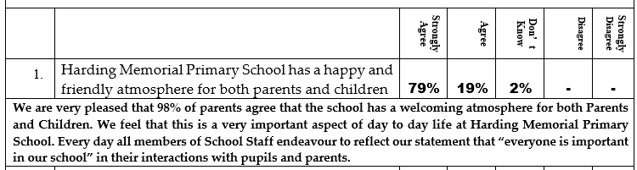

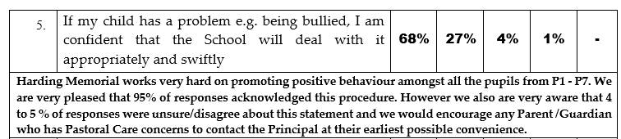

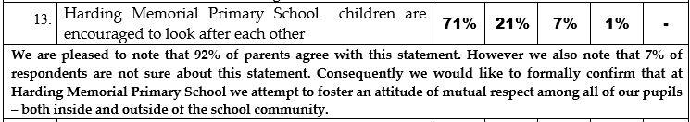

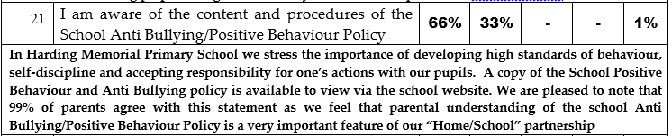

The School Principal is planning to distribute a “Board of Governors Parent/Guardian Pastoral Care Questionnaire” to all School Families in June 2019. This questionnaire will be an addendum to a previous Anti Bullying Questionnaire that was previously issued to Parent/Guardians in December 2016. In addition the Principal is keen to “access the pupil voice” and consequently there will be consultation about the views of pupils through the use of a Pupil Council Questionnaire and the P7 ARK Online Survey during the incoming 2019/2020 School Year. It is provisionally planned that there will also be formal engagement with School Stakeholder Groups – the Parent, Teacher and Friends Committee – about the topics of School Pastoral Care, Discipline and Anti Bullying during 2019/2020. The Principal has arranged to meet with Education Authority Support Staff responsible for the implementation of the Addressing Anti Bullying Act 2016 in May 2019.

**What is the definition of Bullying at Harding Memorial Primary School ?**

* The Board of Governors of Harding Memorial Primary School acknowledge that the phrase “bullying” can be a very emotive and challenging term to define. However the Addressing Bullying in Schools Act (NI) 2016 now provides schools **with a legal definition which must be used.**
* The Addressing Bullying in Schools Definition of “bullying” includes (but is not limited to) the repeated use of:

(a) **any verbal, written or electronic communication**

(b) **any other act**

(c) or **any combination of those, by a pupil or a group of pupils against another pupil or group of pupils, with the intention of causing physical or emotional harm to that pupil or group of pupils.**

(2) For the purposes of subsection (1), “act” includes **omission.**

* ***In summary the definition of Bullying at Harding Memorial Primary School is behaviour that is usually repeated, which is carried out intentionally to cause hurt, harm or to adversely affect the rights and needs of another or others.***

Harding Memorial Primary School acknowledges that, while bullying is usually repeated behaviour, **there are instances of one-off incidents that the school will consider as bullying.** When assessing a one-off incident, to make a decision on whether to classify it as bullying, Harding Memorial Primary School will consider the following criteria:

* **Severity And Significance Of The Incident**
* **Evidence Of Pre-Meditation**
* **Impact Of The Incident On Individuals (Physical/Emotional)**
* **Impact Of The Incidents On Wider School Community**
* **Previous Relationships Between Those Involved**
* **Any Previous Incidents Involving The Individuals**
* **The following unacceptable behaviours, when repeated, targeted and intentionally hurtful, may be considered as bullying behaviour in Harding Memorial Primary School:**
* **Verbal or written acts**
* **saying mean and hurtful things to, or about, others**
* **making fun of others**
* **calling another pupil mean and hurtful names**
* **telling lies or spread false rumours about others**
* **try to make other pupils dislike another pupil/s**
* **Physical acts**
* **Hitting**
* **kicking**
* **pushing**
* **shoving**
* **material harm, such as taking/stealing money or possessions or causing damage to possessions**
* **Omission (Exclusion)**
* **Leaving someone out of a game**
* **Refusing to include someone in group work**
* **Electronic Acts**
* **Using online platforms or other electronic communication to carry out many of the written acts noted above**
* **Impersonating someone online to cause hurt**
* **Sharing images (eg. photographs or videos) online to embarrass someone**
* The Board of Governors of Harding Memorial Primary School acknowledge that this policy list of behaviours is not exhaustive and that other behaviours which fit with the definition may be considered bullying behaviour. Any incidents which are not considered bullying behaviour will consequently be addressed under the School Positive Behaviour Policy.
* The Safeguarding Team at Harding Memorial Primary School will consider it good practice to try to explore or examine any possible motivations relating to possible bullying behaviours e.g Age, Appearance, Breakdown in peer relationships, Community background, Political affiliation, Gender identity, Sexual orientation, Marital status, Race, Religion, Disability / SEN, Ability, Looked After Child status and Young Carer status etc
* In accordance with the guidance contained within the Addressing Bullying in Schools Act (Northern Ireland) 2016 and the Addressing Bullying in Schools Act (Northern Ireland) 2016 Statutory Guidance for Schools and Boards of Governors (DE, 2019) the use of the terms “bully’” and “victim” will be actively avoided in Harding Memorial.
* Harding Memorial acknowledges that “Bullying” is an emotive issue and therefore it is essential that we ensure we use supportive, understanding language when discussing these matters.
* For that reason we will not refer to a child as a “bully”, nor will we refer to a child as a “victim”. Instead, we will refer to the child describing the situation surrounding that child, for example:
* **A child displaying bullying behaviours**

**or**

* **A child experiencing bullying behaviours**
* It is Harding Memorial Primary School Policy that encourage all members of the School Community will use this language when discussion of “alleged bullying incidents”.
* In summary Harding Memorial Primary School will seek to immediately address any and all incidents of behaviour that is usually repeated, which is carried out intentionally to cause hurt, harm or to adversely affect the rights and needs of another or others eg.

* **Physical** (e.g. hitting, kicking) Physical harm as intentionally hurting a pupil by causing injuries such as bruises, broken bones, burns or cuts
* Verbal (e.g. name calling)
* Non Verbal (e.g. excluding someone from a group by action)
* Emotional (e.g. when it causes someone to lose self-esteem). Emotional or psychological harm as intentionally causing distress or anxiety by scaring, humiliating or affecting adversely a pupil’s self-esteem.

**Preventative Anti Bullying Measures at Harding Memorial Primary School**

The Principal is very proud of the positive atmosphere and ethos that is apparent on a daily basis amongst pupils, parents, staff and the wider local community. However the Board of Governors is not complacent and is aware of the ongoing necessity to regularly monitor and evaluate the “ethos” of the school in order to fulfil the school mission statement – Everyone is important in our school. The Board of Governors are in agreement with the statement that the focus for all anti-bullying work in Harding Memorial Primary School should be on “prevention” – we intend to be proactive and not reactive. This is of particular importance with regards to school ethos. Glover and Law have stated that *“Effective Teaching and Learning requires the support of a forward thinking culture stemming from a strong, and widely accepted, whole school ethos”*. But having an intake of academic students does not in itself mean a school has an academic ethos. Having friendly staff does not in itself mean the school has a friendly ethos. In a school with a strong ethos a pupil can learn in any classroom and know that certain actions will be met with comparable responses regardless of classroom, subject or teacher. Even more importantly, if the ethos is well established, all pupils will know exactly why a certain action produces a certain response. It is the intention of this Anti- Bullying Policy that all pupils will know what is not permitted, as well as what is allowed and encouraged.

The Board of Governors are pleased to note that there is statistical information available from regular survey of School Stakeholders that indicates that Harding Memorial has a “good reputation” in the local community. All School Staff encourage the development of a culture where pupils take pride in our school and are consequently viewed as ambassadors for their school within the community e.g “the children are the best advert for our school”. Harding Memorial Primary School uses a variety of methods to challenge inappropriate and unacceptable pupil behaviour both inside and outside of the school environment e.g the behaviour of pupils at the local Loop River Play Park has been mentioned during whole school assemblies and during P7 Transition to Secondary School Workshops. In addition the Principal is very keen to ensure a visible presence both when children enter and exit school on a daily basis.

Harding Memorial Primary School Teaching and Non-Teaching Staff provide “preventative” Anti- Bullying work throughout the school year e.g NI Anti- Bullying Week in November, Safer Internet Day, PDMU work in school is linked to the various aspects of pupils keeping themselves safe and enhancing their self-esteem, etc. All children throughout the school experience age-appropriate educational experiences relating to the promotion of positive behaviour and inclusion. The preventative curriculum at Harding Memorial actively promotes positive emotional health and wellbeing amongst all members of the School Community as well as encouraging the celebration of diversity amongst our school community e.g different languages. Upper KS2 receive specific reminder about the School “zero tolerance” policy towards any sectarian, racist, homophobic and disablist comments.

There is an effective Pupil Council at Harding Memorial Primary School that provides support for the Pupil Voice. The Pupil Council and P7 Helpers help to support the delivery and promotion of key anti-bullying messaging throughout the School especially during “Playground Playtime” e.g peer intervention in playground football via a pupil referee, the mentoring of Foundation Stage Pupils etc.

Professional Development Training Support has been provided for School Lunchtime and Non-Teaching Supervisory Staff regarding the “zoning” of playgrounds, inclusion of specific resources (buddy benches etc) and provision of a variety of play options to meet the needs of all pupils. The Harding Hero Positive Behaviour Scheme and Focussed Pupil Assemblies help to raise awareness and promote understanding of the key issues related to the prevention of bullying in school e.g Fairness, Respect. The views of all School Staff – Teaching and Non-Teaching are referenced by the School Management Team when addressing aspects of pupil conflict e.g is this behaviour different in class and in playground etc

The Harding Memorial Primary School Board of Governors acknowledge that the “new” Addressing Anti Bullying legislation states that school must indicate within their Anti Bullying policy the preventative measures they will put in place to prevent bullying behaviour on the way to and from school. Whilst the Principal is hopeful that the continued development of an anti-bullying culture will remedy any such unfortunate situations, the Principal can confirm that HMPS will make sure that any children experiencing concern about “walking home from school” for any reason will be given appropriate support e.g Parent being contacted by School, being able to wait on at school for pick up or adult support “walking home”.

Harding Memorial Primary School is proactive in addressing the issue of potential bullying through the use of electronic communication, especially where that behaviour is likely to have a detrimental effect on the pupil’s education at school e.g Hoax Mobile Phone Chain Text Messages. The School has in the past provided each School Family with a “Copy of Vodaphone Digital Parenting Magazine”: [www.vodafone.com/content/dam/vodafone/parents/assets_2013/pdf/vodafone_digital_parenting_issue3_low_res.pdf](http://www.vodafone.com/content/dam/vodafone/parents/assets_2013/pdf/vodafone_digital_parenting_issue3_low_res.pdf). The purpose of this documentation is to support both Pupils and Adults as our P6 & P7 pupils range in age from 9 to 11 years and they are still on the cusp of being able to do the kind of thinking that allows them to view such text messages critically and recognize them for what they are – “cruel hoaxes” that have been designed with malicious intent to create harm and distress to those individuals who have been unfortunate enough to receive such unwanted correspondence. Additional copies of this documentation are available for each School Parent/Guardian upon request from the School Principal.

Although the terms and conditions of using Facebook state that the **user** ***must be 13 years or over***, the Principal is aware that there are some children within Harding Memorial Primary School who are using Facebook and other such social media networking sites. However if a child at Harding Memorial Primary School has a Facebook Account then they have already ***broken the terms of the site*** as they must have uploaded false information about their age. Harding Memorial Primary School does **not condone the use of Facebook** nor do we encourage it or the use of any other social networking site. In Harding Memorial Primary School all social networking sites are automatically blocked for pupil use by our school internet filters. As part of the School Pastoral Care policy we will continue to inform parents of any issues that we become aware of in school with regard to the inappropriate use of social networking sites.

However if a Parent/Guardian continues to wish for their child/children to use this technology we **would strongly urge every parent/guardian to talk to their child/children about their use of the internet.** For example we would we encourage all HMPS Parent/Guardians to please check with their child/children:

* What are they posting online?
* Who can see it?
* Are they sharing their age, address, e-mail or phone number on Facebook?
* Are they inappropriately asking to become friends with teachers and other staff members? We as a school do not permit any form of ICT or modern communication technologies (e-mail, texting, facebooking or the use of any other social networking site) to be used as a means of communication about school matters between staff and pupils or staff and parents.
* For primary aged children it is more appropriate to use a cartoon photo as their personal photo than an actual photo
* It is important to help your child to understand that they should not post any photo they would not wish their mum, dad or granny to see. They should also understand that even if they are careful about privacy settings – their electronic ‘friends’ might not be (and that means that others can ‘take’ or ‘harvest’ photos from their web space if they are not stored privately).
* **A Final Point To Remember**: Many people do share information online without thinking about the possible consequences! Once information is shared online, it is very hard (often impossible) to remove. The following link may also be helpful for Parent/Guardians in deciding how to pitch your safe talk with their child(ren): [**www.thinkuknow.co.uk/parents**](http://www.thinkuknow.co.uk/parents)

Harding Memorial Primary School strongly discourages Primary School Age Pupils from bringing mobile phones to school. However, we fully acknowledge a parent’s right to allow their child to bring a mobile phone to school due to Exceptional Pastoral Care Circumstances. Nevertheless, these exceptional circumstances should be discussed beforehand with the Principal, Mr Cumper, either by personal contact or by providing a written request from the child’s Parent/Guardian. If a pupil has been granted *“permission by the School Principal to bring a Mobile Phone to School*”, it is expected that this Mobile Phone will remain switched off while pupils are in class, the school building and the school grounds. Should parents need to contact pupils, or vice versa, this should be done following the usual school procedures: via the school office and Mrs Shannon or Mr Cumper. If a pupil is found taking photographs or video footage with a mobile phone of either other pupils or teachers, this will be regarded as a serious offence and disciplinary action will be taken according to the School’s Discipline Policy. Parents are advised that Harding Memorial Primary School accepts no liability for the loss or damage to mobile phones which are brought into the school or school grounds. We would encourage all Parent/Guardians to take time to talk to their children about who is entitled to use his/her mobile number and the potential danger of misuse of text messages with the associated risks of potential Cyber Bullying. Should a child be found to have access to inappropriate images on a mobile phone – we would view this as a very serious issue - **and will immediately seek the advice of the Education Authority on how to address this potentially very significant issue of Child Protection and School Discipline.**

**Responsibilities for Addressing Bullying at Harding Memorial Primary School**

Everyone in Harding Memorial has responsibility for creating a safe and supportive learning environment for all members of our school community. All School Stakeholders - pupils, parents/carers and staff – are expected to respect the rights of others to be safe. Everyone has the responsibility to work together to:

* foster positive self-esteem
* behave towards others in a mutually respectful way
* model high standards of personal pro-social behaviour
* be alert to signs of distress* and other possible indications of bullying behaviour
* inform the school of any concerns relating to bullying behaviour
* refrain from becoming involved in any kind of bullying behaviour, even at the risk of incurring temporary unpopularity.
* refrain from retaliating to any form of bullying behaviour
* intervene to support any person who is being bullied, unless it is unsafe to do so.
* report any concerns or instances of bullying behaviour witnessed or suspected, to a member of staff.
* emphasise the importance of seeking help from a trusted adult about bullying behaviour when it happens or is observed
* explain the implications of allowing the bullying behaviour to continue unchecked, for themselves and/or others.
* listen sensitively to anyone who has been bullied, take what is said seriously, and provide reassurance that appropriate action will be taken
* know how to seek support – internal and external
* resolve difficulties in restorative ways to prevent recurring bullying behaviour and meet the needs of all parties
* Harding Memorial Primary School will use a mixture of the following strategies to attempt to be proactive in addressing and reducing any instances of pupils displaying bullying behaviours:
* A code of conduct followed by all staff, in line with Education Authority (Belfast Region) policy.
* A School Management Team (S.M.T.) to monitor behaviour – Mr Cumper (Principal) and Mrs Baird (Vice Principal) with the assistance of additional members of School Staff when deemed appropriate
* Agreed procedures for responding to incidents – teacher reports to a member of the S.M.T. who will assist in contacting parents and talking to children.
* Written Procedures for logging incidents (Individual Teacher Behaviour Book) & a system for electronic recording of “bullying incidents” that will be formally introduced starting in 2019/2020.
* Communicate the Anti Bullying Policy to all members of the school community.
* Ensure through the School Positive Behaviour Policy that pupils, staff and parents are aware of their responsibilities.
* Encourage positive attitude to Anti Bullying within school through ‘Circle Time’ and class discussions.
* Periodically review the training needs of all staff.
* Use Revised Curriculum Personal Development and Mutual Understanding School Resources (PDMU)
* Provide appropriate advice for both victims and perpetrators.

Individual Responsibilities at Harding Memorial Primary School

All Harding Memorial Primary School Teaching and Non-Teaching Staff should:

1. Take all reports of bullying seriously
2. Log all incidents
3. Communicate with all concerned, in line with established school policy and procedures
4. Participate in training
5. Acknowledge appropriate behaviour

All Pupils should:

1. Report all incidents of bullying and alleged bullying to a supervising adult as soon as possible
2. Respect and support peers
3. Adhere to and promote the school’s anti-bullying policy

All Parent/Guardians should:

1. Promote good social behaviour
2. Report any concerns to the school as soon as possible

Actively support the school’s anti-bullying policy

**Reporting a Bullying Concern at Harding Memorial Primary School**

The School Principal is the Designated Teacher for Child Protection (Mr Cumper) and the School Vice Principal (Mrs Baird) is the Deputy Designated Teacher for Child Protection (Mrs Baird). A Child Protection/Pastoral Care Poster is displayed in each classroom alongside a picture of both the DT and DDT with the statement that children should speak to either individual - “If They Are Worried”. All children in Harding Memorial are encouraged to speak to any member of School Teaching or Non-Teaching Staff if they are unhappy about anything in school, including any Bullying concern. There are various methods in which our pupils can raise concerns about Bullying in HMPS e.g verbally- talking to a member of staff, by writing a note to a member of school staff (eg. in a homework diary or by posting a comment in a ‘worry/suggestion box’ etc. It is recommended school policy that ANY pupil can raise a concern about bullying behaviour, not just the pupil who is experiencing this behaviour. The central message of the School Anti- Bullying Policy is a focus on “getting help” rather than “telling”. As such, all pupils in our School should be encouraged to “get help” if they have a concern about bullying that they experience or is experienced by another child/children. The Principal is very keen to continue to promote the message that we are a School Family and that it is “ok” to ask for help. The Principal is very keen to dissuade the use of “name calling terms” such as Grass, Tout, Tell-tale etc as such negative terminology is not in accordance with the aims, rationale and ethos of the School Anti-Bullying Policy.

**Reporting a Bullying Concern by Parent/Guardians**

The Board of Governors has previously consulted with Parent/Guardians via an Anti - Bullying Questionnaire in December 2016 and is aware that a significant number of respondents replied in the affirmative to the statement that *“I believe that on occasions it is appropriate for a child to physically defend himself/herself to stop other people “picking on them”.* Nevertheless it should be noted that Harding Memorial Primary School strongly supports the viewpoint of Carrie Goldman that, even if a child does succeed in hitting back, (whether through physical intimidation or verbal taunts or cyberbullying), this merely teaches kids to “out-bully” each other, rather than to focus on restoration and restitution.

When any Parent/Guardian has a Bullying Concern, they should in the first instance, report that bullying concern to their child’s Class Teacher. The Class Teacher will then inform a member of the School Management Team – Mrs Baird or Mr Cumper. It is accepted School Policy that all School Staff – Teaching and Non-Teaching - will discuss any *“child/children displaying bullying behaviours”* with a member of the School Management Team immediately. The S.M.T. will then decide what further action is appropriate including informing the Parent/Guardians of any child/children who has/have been “experiencing bullying behaviours” if they are unaware of the problem. The Parent/Guardians of the “child/ children who has/have been accused of displaying bullying behaviour***”*** will also be informed at the same time.

All reports of bullying concerns received from Pupils and/or Parent/Guardians will be responded to in line with the School Anti- Bullying Policy and it is recommended good practice that feedback will be made to the person who made the report from the Class Teacher or a member of the School Management Team. However, it must be noted that no information about action taken in relation to a pupil can be disclosed to anyone other than the Pupil and his/her Parent/Guardians.

In circumstances whereby a Parent/Guardian is not satisfied that appropriate action has been taken by School to prevent further incidents, or where further incidents have taken place, the concern should be immediately reported to the School Principal. The Principal will they try to arrange a meeting with the Parent/Guardian at their earliest possible convenience in an attempt to satisfactorily resolve the situation. However if a Parent/Guardian still remains unsatisfied that in their opinion the concern has not been appropriately responded to, then the Parent/Guardian has the option of following the School’s Complaints Procedure. A copy of the School Complaints Policy is available from the school office or via the School Web Site and will usually involves making a formal, written complaint, to the Chair of the Board of Governors – Mr Gerry Fleming.

A summary graphic of the Complaints Procedure is listed below. If following Stage Two you remain dissatisfied with the outcome of your complaint, you can refer the matter to the Office of the Northern Ireland Public Services Ombudsman (NIPSO). The Ombudsman provides a free, independent and impartial service for handling complaints about schools in Northern Ireland. You have the right to complain to the Ombudsman if you feel that you have been treated unfairly or have received a poor service from a school and your complaint has not been resolved to your satisfaction. A complaint should normally be referred to NIPSO within six months of the final response from the School. The school must advise in its concluding letter that the complaint may be referred to the NIPSO if you remain dissatisfied.



**Responding to a Bullying Concern**

Harding Memorial Primary School believes that all bullying is unacceptable. In accordance with the aims and objectives of the School Anti-Bullying Policy, the focus of all interventions by School Staff will be on responding to the bullying concern and restoring the wellbeing of those involved. As such, any strategy for responding to bullying concerns will concentrate on the prevention of any further incidents The processes outlined below provide a framework for how Harding Memorial Primary School will respond to any bullying concerns identified through using the Northern Ireland Anti Bullying Forum (NIABF) Effective Responses to Bullying Behaviour Resource. It is recommended “good practice” in our School that each member of School Staff responsible shall respond as follows:

* Clarifying facts and perceptions (including any previous instances of “alleged bullying behaviours”
* Assessing the incident against the criteria for bullying behaviour
* Identifying any themes or motivating factors
* Identifying the type of bullying behaviour “allegedly” being displayed
* Identifying an appropriate intervention level
* Selecting and implementing appropriate interventions for all pupils involved, including appropriate interventions, consequences and sanctions not listed in the Effective Responses to Bullying Behaviour resource
* Tracking, monitoring and recording the effectiveness of interventions
* Reviewing the outcome of interventions
* Selecting and implementing further intentions as necessary

All Harding Memorial Primary School Teaching and Non-Teaching Staff will adopt a positive mind set when responding to bullying concerns in our School. Our Staff will attempt to respond to all incidents of “alleged bullying behaviours” in a planned, deliberate and positive way. The following strategies will be implemented by all School Staff when managing a situation of “bullying”.

* **Being calm -** It is important to be clear thinking and emotionally in control.
* **Being positive -** Have in mind the importance of maintaining a positive relationship with the pupil. A pupil is much more likely to modify his/her behaviour if he/she perceives that an adult cares.
* **Being assertive -** Staff should directly and clearly express their thoughts, feelings and expectations concerning the need for the pupil to not only stop displaying bullying behaviours, but also make restitution with the child who has been experiencing bullying behaviours.
* **Being confident -** It is important to trust that you will be successful in implementing practices that can have an impact on the pupil’s future behaviour. It is always helpful to focus on the behaviour, not the pupil.
* Assessing the situation and its severity level - determining the appropriate level of response required to manage the situation effectively e.g Level 1 – Level 4 from NIABF Effective Responses to Bullying Behaviour. The various “Levels” suggested within this document are for guidance only, and it is important to remember that every “bullying” incident should be individually assessed and an intervention chosen which best meets the needs of the individual pupil(s).

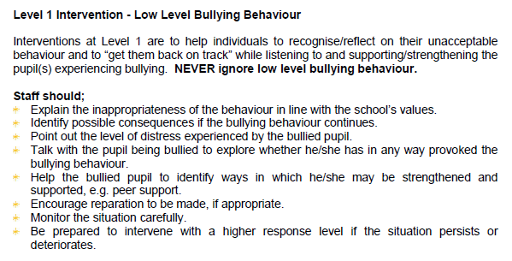

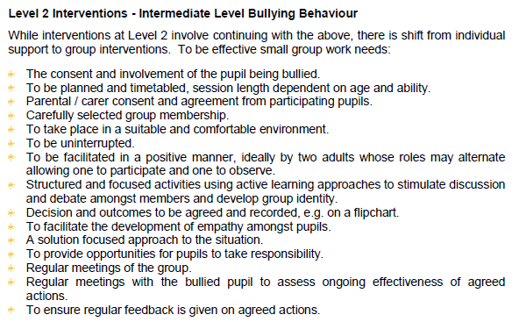

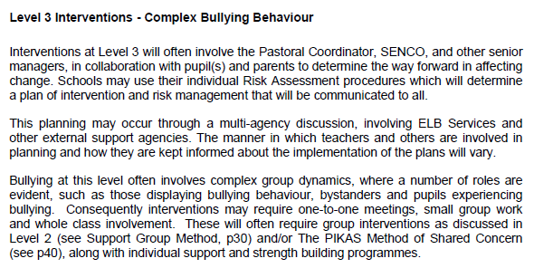

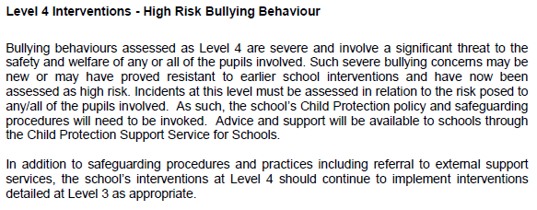

Harding Memorial Primary School advocates a restorative approach to responding to “children displaying bullying behaviours” e.g a “Solution Focussed Approach” whereby children can suggest ways to change the behaviour that has been linked to any “alleged bullying incident” Circle Time etc.

When responding to a bullying concern, school staff shall implement interventions aimed at responding to the behaviour, resolving the concern and restoring the wellbeing of those involved. Where and when appropriate, school staff may implement sanctions for those displaying bullying behaviour including consequences and sanctions. A possible set of sanctions and their progression of levels in listed below: Level 1 to Level 3 progressing in severity and seriousness.

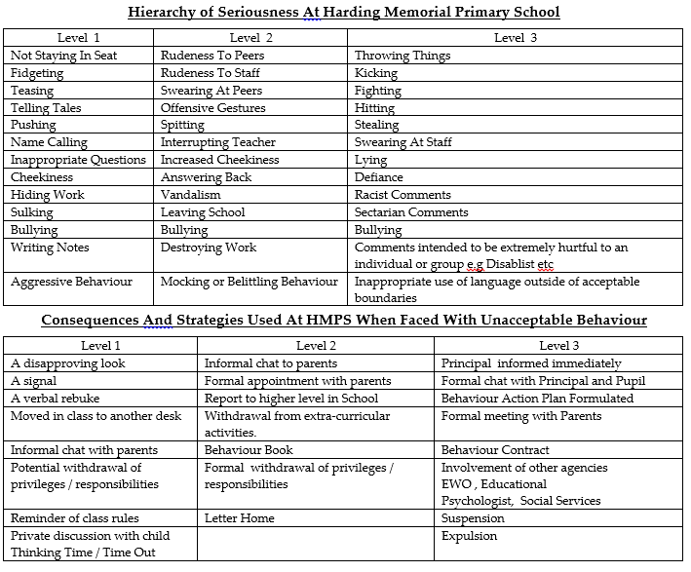

# Possible Examples of Inappropriate Behaviour and Sanctions - These are only possible examples to illustrate a possible hierarchy in Inappropriate Behaviour and Possible Sanctions and that this list may be subject to amendment or alteration when deemed appropriate by the School Management Team.

Procedures For Investigating An “Alleged” Bullying Concern at Harding Memorial Primary School. School Teaching and Non-Teaching Staff may apply one or more of the strategies below, depending on the perceived seriousness of the situation. The emphasis will always be one of showing a caring and listening approach to both the child displaying bullying behaviours and the child experiencing bullying behaviours

1. Discuss the nature of the “alleged incident” with the child/children who feel that they have been “experiencing bullying behaviours” at length, recording all the facts. This will require patience and understanding.
2. Identify the child/children “alleged” to have “displayed bullying behaviours” and any potential witnesses.
3. Speak to the witnesses.
4. Discuss the incident(s) with the child/children alleged to have demonstrated “bullying behaviours”. Discuss the “allegations” of “bullying behaviours” with the individual(s) and ask he/she/them to tell the truth about the situation/incident. Make it clear to the children involved that this is only an investigation at this stage.
5. If a child/children confirms that they have been involved in “behaviours that could be described as bullying”, make it clearly understood to those children that “Bullying is not acceptable in our School”. Discipline sanctions may then be applied that are relevant and appropriate to the type of the “confirmed bullying behaviours”.
6. If the allegation of bullying is “denied”, then investigate further. If there is sufficient “clear and verifiable evidence” that the incident of bullying has occurred, then relevant sanctions will be applied.
7. If it is required, there will separate discussions with the Parent/Guardians of the children involved.
8. Possible sanctions for the child/children “confirmed of displaying bullying behaviour” may include: Withdrawal from favoured activities, for example after school activities, Loss of playtimes for a period to be determined by the Principal, After School detention etc .
9. Provide a Pastoral Support Programme for the victim with a mentor/named person (usually a member of the SMT monitoring and observing at break times and lunchtimes) and through discussion to make sure there is no repetition of these “bullying behaviours”.
10. Provide a Pastoral Support Programme for the child/children who have had confirmed incidents of demonstrating “bullying behaviours”. This will include opportunities in circle time or groups for the child/ren to discuss relationships, feelings and the effect bullying can have on individuals.
11. In the event of sustained “bullying behaviours” between pupils and continuing “relationship conflict” the Chairman of the Board of Governors will be informed. At this stage the Parent/Guardians may be invited to attend a meeting to discuss the matter with the Chairman of the Board of Governors and the School Principal. The Governors and Principal may refer the matter to the Education Authority (Belfast Region) for advice and guidance, at any stage.
12. Even with a positive behaviour approach there are times when sanctions will be necessary. They are necessary for two main reasons: To protect the authority of the teacher and other members of staff and to make the individual child and others aware of what is and is not acceptable behaviour within the local school environment.

**Rights And Responsibilities Of The Pupil at Harding Memorial Primary School:** It is hoped that the pupils at Harding Memorial Primary School will enjoy their education. Every child has the right to feel safe and secure, while they are learning. As a result, every effort will be made to have their individual needs met by the staff as a whole. At the same time, we wish to encourage pupils to see that other children deserve and must enjoy the same treatment as they do.

**Role And Responsibilities Of The Parent/Guardian at Harding Memorial Primary School:** As was mentioned before, Parents must take some responsibility for the discipline of their children. The basis for good discipline lies jointly with parents, pupils, teaching staff, principal and the Board of Governors. For good discipline to be maintained, all members of this partnership must co-operate. Parents are encouraged to take an interest in what their child does at school and try to support the teaching staff, where possible. Parents may consult with the Principal at any stage. If they wish to consult a member of staff other than the Principal they must first contact the Principal to arrange an appointment with that member of staff.

**Role Of The Teacher at Harding Memorial Primary School:** The Teacher’s role is to provide education for the children. When the children and the teacher understand and accept their different roles good discipline can be achieved. Teachers should set out clearly and in simple terms the rules by which they wish to run their classrooms. In all cases children should be given the opportunity to formulate and take ownership of the rules under the guidance of the class teacher. In the event of misbehaviour, they should use whatever sanctions / reprimands they deem necessary (in line with the guidelines laid out in the Positive Behaviour Policy), to restore good discipline. Should all action fail to bring about the desired effect, teachers may refer the pupil to the Principal for further action. Co-operation with parents may overcome the problems, so it is vital that the teacher tries to work in partnership with the parents, whenever possible.

**Role Of The Principal at Harding Memorial Primary School:** The Principal has a key role to play in formulating and reviewing the Positive Behaviour Policy, and establishing the ethos of the school. He must convince pupils and teachers that they have a vital role to play in the life and organisation of the school. The Principal must ensure that the rules of the school are administered fairly and consistently to all pupils. The Principal will furnish the Board of Governors and the Education Authority with a report on the discipline within the school or the discipline of an individual pupil if and when necessary.

**Recording of a Bullying Concern at Harding Memorial Primary School**

The Board of Governors of Harding Memorial Primary School acknowledge the legal requirement, as set out in the Addressing Bullying in Schools Act (NI) 2016, to maintain a record of all incidents of bullying and alleged bullying behaviour. Harding Memorial Primary School will centrally record all relevant information related to reports of bullying concerns, including:

* how the bullying behaviour was displayed (the method)
* the motivation for the behaviour
* how each incident was addressed by the school
* the outcome of the interventions employed.

Harding Memorial Primary School is aware that the Department of Education guidance to schools encourages the use of the SIMS Behaviour Management Module for record keeping. However the School Principal is of the professional opinion that this system would not be “a good fit” for the educational context of our School. Instead after consultation with School Teaching Staff the School Management Team is planning to introduce an alternative electronic recording system at the commencement of the 2019/2020 School Year. All records will be maintained in line with relevant data protection legislation and guidance and will be disposed of in line with the school’s Retention and Disposal of Documents Policy. Collated information regarding incidents of bullying and alleged bullying behaviour will be used to inform the future development of anti-bullying policy and practice within Harding Memorial Primary School.

**Professional Development of Staff at Harding Memorial Primary School**

The Department of Education policy on school improvement now places a greater onus on Teachers to: ***“identify their own training and support needs as part of the process of self-evaluation, self-assessment and capacity building, in line with the Teacher competence framework drawn up by the General Teaching Council, ‘Teaching: the Reflective Profession.’”***

At Harding Memorial Primary School we believe that the opportunity to develop professionally and personally both improves standards and raises morale through personal and professional fulfilment and that this in turn assists recruitment and retention. All School Staff, Teaching and Non - Teaching shall have an entitlement to equal access to high-quality induction and Continuing Professional Development. All members of the school community at Harding Memorial Primary School will have opportunities through performance management, appraisal and through other mechanisms to discuss their professional development needs. In order to maintain effective Continuing Professional Development we will undertake regular reviews of our CPD. The emphasis of CPD at Harding Memorial Primary School will be to improve the standards and quality of teaching and learning. Our CPD planning will be inextricably linked and integrated with the School Development Plan and will be based on a range of the following information:

* The Needs Of The School As Identified Through Self-Evaluation Of The School Development Plan
* Issues Identified Through Other Monitoring Eg. Board of Governors Questionnaire
* Feedback From School Staff And Others Including Governors, Pupils And Parents

The Principal will provide the Board of Governors regular written updates about School Staff Professional Development and will ensure that opportunities for safeguarding training are afforded to all School Teaching and Non - Teaching Staff as well as the Governing Body itself.

**Monitoring and Review of the Anti- Bullying Policy at Harding Memorial P.S.**

The Harding Memorial Primary School Board of Governors will continue to work in liaison with the School Management Team (P and VP) to monitor the effectiveness of the Anti-Bullying Policy, especially during the initial implementation of this policy during the 2019/2020 academic year . In order to appropriately monitor the effectiveness of the Anti-Bullying Policy, the Honorary Secretary to the Board of Governors will continue to maintain a standing item on the agenda of each meeting of the Board where a report on recorded incidents of bullying and pastoral care incidents will be noted: ***Current Issues.*** This section of the Board of Governors Agenda will identify trends and priorities for action, assess the effectiveness of strategies aimed at preventing bullying behaviour and assess the effectiveness of strategies aimed at responding to bullying behaviour.

The Board of Governors of Harding Memorial Primary School acknowledge that it is a legal requirement that the School Anti-Bullying Policy should be reviewed at intervals of no more than four years. However, it should also be noted that it is currently regarded as “Good Practice” in our School to “conduct a review” into any and all school policies following any incident which has “highlighted the need for such a review”. The Principal is of the opinion that it would be prudent to conduct a review of this policy at the conclusion of the first year on operation – 2019/202. In addition the Principal is aware that this Policy will need to be reviewed when directed to by the Department of Education and in light of new guidance. In the development and implementation of this Anti-Bullying Policy, the Board of Governors has been mindful of related policies, including:

* Positive Behaviour Policy & Discipline Policy
* Pastoral Care Policy
* Safeguarding and Child Protection Policy
* Special Educational Needs Policy
* Health and Safety Policy
* Relationships and Sexuality Education
* E-Safety Policy & Acceptable Use of Internet Policy
* Mobile Phone Policy
* Educational Visits
* Staff Code of Conduct



How Can You Tell If A Child Is Being Bullied ?

A List of “Possible” Indicators

**Possible Behavioural Symptoms**

1. Does not want to come to school.
2. Has damaged or lost clothing or possessions.
3. Arriving late for school
4. Avoiding friends at school
5. Is doing poorly at their work
6. Refusing to tell what’s wrong

**Possible Physical Symptoms**

1. Sleeps badly or cries at night.
2. Stops eating.
3. Unexplained bruises.
4. Has mystery illness
5. Feels sick frequently in class

**Possible Emotional Symptoms**

1. Becomes easily startled, irritable or aggressive
2. Is quieter than usual, withdrawn or distressed.
3. Loss of confidence
4. Bursts into tears

## 

###### HARDING MEMORIAL PRIMARY SCHOOL

###### ANTI BULLYING & DISCIPLINE CHANNELS AT HMPS

Lunchtime Supervisors

Education Authority

(Belfast Region)

Board of Governors

Principal

S.M.T.

Class Teachers

Classroom Assistants

Ancillary Staff