Harding Memorial Primary School
Child Protection & Safeguarding Policy
March 2019

- Date ratified by Board of Governors: March 2019
- Date of Review: May 2020 – or at an earlier time if deemed necessary by School Safeguarding Team Personnel – e.g Designated Teacher, Deputy Designated Teacher, Designated Governor or Chairperson of the Harding Memorial Board of Governors.

Contents of Child Protection & Safeguarding Policy | Page Number
Our School’s Mission Statement | 3
Related Policies | 3
The School’s Safeguarding Team | 4 - 6
Definitions of Harm | 7
Responding to a Safeguarding Concern | 8
Consent, Confidentiality, Information Sharing and Record Keeping | 9
Safe Recruitment Procedures | 10
Code of Conduct | 11
The Preventative Curriculum | 11
Monitoring and Evaluation | 11-12
Appendices:
Appendix 1 Specific Types of Abuse | 13 - 18
Appendix 2 Children with Increased Vulnerabilities | 19-21
Appendix 3 How a Parent Can Make a Complaint | 22
Appendix 4 Procedure Where the School Has Concerns about Possible Abuse | 23
Appendix 5 Dealing with Allegations of Abuse against a Member of Staff | 24
Appendix 6 Note of Concern | 25-26

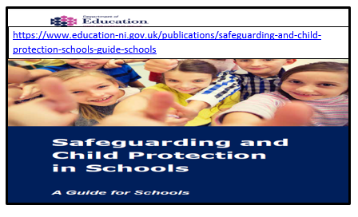

Everyone within Harding Memorial Primary School has a responsibility for the safeguarding and child protection of the children in our care and we will carry out this duty by providing a caring, supportive and safe environment, where each child is valued for his or her unique talents and abilities, and in which all our young people can learn and develop to their full potential. All School Teaching and Non-Teaching Staff will be alert to the signs of possible abuse and should know the procedures to be followed. This Child Protection & Safeguarding Policy sets out guidance on the action, which is required where abuse or harm to a child is suspected and outlines referral procedures within our school.

Key Principles of Safeguarding and Child Protection

The general principles, which underpin our work, are those set out in the UN Convention on the Rights of the Child and are enshrined in the Children (Northern Ireland) Order 1995, “Co-Operating to Safeguard Children and Young People in Northern Ireland” (DOH, 2017), the Department of Education (Northern Ireland) guidance “Safeguarding and Child Protection in Schools” (DENI Circular 2017/04) + the Safeguarding Board for NI Core Child Protection Policy & Procedures (2017).

The following Principles form the basis of the Child Protection Policy at HMPS

- the child or young person’s welfare is paramount
- the voice of the child or young person should be heard
- parents are supported to exercise parental responsibility and families helped stay together
- partnership and prevention
- responses should be proportionate to the circumstances
- protection
- evidence based and informed decision making

Harding Memorial Primary School has a duty to ensure that safeguarding permeates all activities and functions. The child protection policy therefore complements and supports a range of other school policies including:

- Anti-Bullying Policy
- Attendance Policy
- Positive Behaviour & Discipline Policy
- Staff Code of Conduct Policy
- School Complaints policy
- Data Protection Policy
- Educational Visits Policy
- E-Safety Policy
- First Aid and Administration of Medicines Policy
- Health and Safety Policy
- Intimate Care Policy
- Privacy Notice Policy
- Records Management Policy
- Relationships and Sexuality Education Policy
- Special Educational Needs Policy
- Use of Mobile Phones in School Policy
- Use of Reasonable Force/Safe Handling Policy
- Whistleblowing Policy
The School Principal, Mr Cumper, would be most willing to discuss the contents of any and all School Policies with any and all stakeholders connected to our School. In addition a copy of any of these policies will be made available to any Parent/Guardian upon request from the School Office. In addition certain “Key School Policy Documents” can also be accessed via the Harding Memorial Primary School Website www http://www.hardingmemorial.org.uk. However it should be noted that the School Web Site is in the process of being revised and upgraded.

- Harding Memorial Primary School Safeguarding Team

The 4 individuals listed below are members of the Harding Memorial Safeguarding Team

- Chair of Board of Governors: Mr Gerry Fleming
- Designated Governor for CP: Mrs Dawn Mayes
- Principal & Designated Teacher: Mr Stephen Cumper
- Deputy Designated Teacher: Mrs Judith Baird
_______________________________________________________________________________________
- Deputy Designated Trained Teacher: Mrs McCausland (FS and KS1 ASC)
- Deputy Designated Trained Teacher: Mrs Morrow (KS2 GLSC)
_______________________________________________________________________________________

- Roles and Responsibilities of the Designated Teacher (Mr Cumper) and the Deputy Designated Teacher (Mrs Baird) at Harding Memorial Primary School

Every school is required to appoint a Designated Teacher with responsibility for Child Protection. The Designated Teacher at Harding Memorial Primary School is Mr Stephen Cumper. They must also appoint a Deputy Designated Teacher. The Deputy Designated Teacher at Harding Memorial Primary School is Mrs Judith Baird. The Designated Teacher and Deputy Designated Teacher are both members of the Safeguarding team and work together to carry out the following duties:

- The induction and training of all School Teaching and Non-Teaching Staff
- Being available to discuss safeguarding or child protection concerns of any member of Staff
- Responsibility for record keeping of all child protection concerns
- Maintaining a current awareness of early intervention supports and other local services e.g. Inner East Family Support Hubs
- Making referrals to Social Services or PSNI where appropriate
- Liaison with the EA Designated Officers for Child Protection (Both Belfast Region and CPSS)
- Lead responsibility for the development of the School’s Child Protection Policy
- Promotion of a safeguarding and child protection ethos in the school
- Compiling written reports to the Board of Governors regarding Child Protection

The Role of the School Principal in Safeguarding at Harding Memorial P.S.

The Principal of Harding Memorial Primary School, Mr S Cumper, is also the School Designated Teacher for Child Protection. This is an organisational arrangement that works for our school as the Principal does not have a full time teaching commitment and is consequently available to attend Child Protection Events e.g Case Conferences at short notice. The School Principal in his formal role as Honorary Secretary to the Board of Governors, also assists the Board of Governors in fulfilling their safeguarding and child protection duties. The Principal will:

- ensure the Board of Governors are kept fully informed of all developments relating to safeguarding including changes to legislation, policy, procedures, DE circulars, inclusion of child protection on the termly meeting agenda
- manage allegations / complaints against school staff
- establish and manage the operational systems for safeguarding and child protection
- appoint and manage designated teacher/deputy designated teachers who are enabled to fulfil their safeguarding responsibilities
- ensure safe and effective recruitment and selection including awareness of safeguarding and child protection for new staff and volunteers
- ensure that parents and pupils receive a copy or summary of the child protection policy at intake and at a minimum every 2 years
- maintain the schools record of child abuse complaints.

The Role of the Board of Governors in Safeguarding at Harding Memorial P.S.
The Board of Governors will ensure that:

- a Designated Governor for Child Protection is appointed
- a Designated and Deputy Designated Teacher are appointed in their schools
- they have a full understanding of the roles of the Designated and Deputy Designated Teachers for Child Protection
- Safeguarding and Child Protection training is given to all School Staff and Governors at Harding Memorial Primary School including refresher training
- the school has a Child Protection policy which is reviewed annually and Parent/Guardians and Pupils receive a copy of the Child Protection Policy and Complaints Procedure every two years
- the school has an Anti-Bullying policy which is reviewed at intervals of no more than four years and maintains a record of all incidents of bullying or alleged bullying. Please see the Addressing Bullying in Schools Act (NI) 2016 which is due to be introduced into HMPS in 2019/2020.
- there is a code of conduct for all adults working in the school
- all school staff and volunteers are recruited and vetted in line with DE Circular 2012/19
- they receive a full annual report on all child protection matters (It is best practice that they receive a termly report of child protection activities). This report should include details of the preventative curriculum and any initiatives or awareness raising undertaken within the school, including training for staff
- the school maintains the following child protection records in line with DE Circulars 2015/13 Dealing with Allegations of Abuse Against a Member of Staff and 2016/20 Child Protection: Record Keeping in Schools.

The Role of the Chairperson of the Board Governors in Safeguarding at HMPS
The Chairperson of the Harding Memorial Primary School Board of Governors will ensure that they:

- have a pivotal role in creating and maintaining a safeguarding ethos
- receives training from CPSS and HR
- assumes lead responsibility in the event of a CP complaint or concern about the Principal
- ensure compliance with legislation, Child Protection record keeping and policies.

The Role of the Designated Governor in Safeguarding at Harding Memorial P.S.
The Designated Governors of the Harding Memorial Board of Governors will ensure that they

- advise the board of governors on the role of the designated teachers
- the content of child protection policies
- the content of a code of conduct for adults within the school
- the content of the termly updates and full annual designated teachers report
- recruitment, selection, vetting and induction of staff.

The Role of School Teaching & Non-Teaching Staff in Safeguarding at HMPS

- All members of Harding Memorial Primary School staff must refer concerns or disclosures initially to the Designated Teacher (Mr Cumper) for Child Protection or to the Deputy Designated Teacher (Mrs Baird) if he is not available.
- (Mrs McCausland in FS and KS1 ASC & Mrs Morrow in the KS2 GLSC) have both previously received Deputy Designated Teacher Training in relation to Child Protection and Safeguarding.
- Individual Class teachers are responsible for informing the DT/ DDT about any and all safeguarding concerns e.g: poor attendance and punctuality, poor presentation, changed or unusual behaviour including self-harm and suicidal thoughts, deterioration in educational progress, discussions with parents about concerns relating to their child, concerns about pupil abuse or serious bullying and concerns about home circumstances including disclosures of domestic abuse
- Harding Memorial Primary School Teaching or Non-Teaching Staff should not give children a guarantee of total confidentiality regarding their disclosures, should not investigate nor should they ask leading questions.
- If any member of Harding Memorial Primary School Teaching or Non-Teaching staff has concerns about a child or staff member they should report these concerns to the Designated Teacher or Deputy Designated teacher if he is not available. A detailed written record of the concerns will be made and any further necessary action will be taken.

The Role of Parent/Guardians in Safeguarding at Harding Memorial P.S.

- The Primary responsibility for Safeguarding & Protection of Children rests with Parent/Guardians who should feel confident about raising any concerns they have in relation to their Child or Children. Parents can play their part in safeguarding by informing the school:

- if the child has a medical condition or educational need
- if there are any Court Orders relating to the safety or wellbeing of a Parent/Guardian or Child
- if there is any change in a Child’s circumstances for example - change of address, change of contact details, change of name, change of Parental Responsibility
- if there are any changes to arrangements about who brings their child to and from school
- if their child is absent and should send in a note on the child’s return to school. This assures the school that the Parent/Guardian knows about the absence. More information on Parental responsibility can be found on the EA website at:

www.eani.org.uk/schools/safeguarding-and-child-protection

- Harding Memorial Primary School acknowledges that it is essential that our Office has access to up to date contact details for each Parent/Guardian. The Principal will continue to stress the importance of “clear and open” communication between Home and School by sending home regular written note reminders about this issue as part of our “established routines”
- The Principal as Designated Teacher for Child Protection and Pastoral Care will deal sensitively with this issue but will also be proactive when communicating with Parents.

Child Protection Definitions at Harding Memorial Primary School

Definition of Harm: Harm can be suffered by a child or young person by acts of abuse perpetrated upon them by others. Abuse can happen in any family, but children may be more at risk if their parents have problems with drugs, alcohol and mental health, or if they live in a home where domestic abuse happens. Abuse can also occur outside of the family environment. Evidence shows that babies and children with disabilities can be more vulnerable to suffering abuse. Although the harm from the abuse might take a long time to be recognisable in the child or young person, professionals may be in a position to observe its indicators earlier, for example, in the way that a parent interacts with their child. Effective and ongoing information sharing is key between professionals.

- Harm from abuse is not always straightforward to identify and a child or young person may experience more than one type of harm. Harm can be caused by:

- Sexual abuse
- Emotional abuse
- Physical abuse
- Neglect
- Exploitation

Sexual Abuse occurs when others use and exploit children sexually for their own gratification or gain or the gratification of others. Sexual abuse may involve physical contact, including assault by penetration (for example, rape, or oral sex) or non-penetrative acts such as masturbation, kissing, rubbing and touching outside clothing. It may include non-contact activities, such as involving children in the production of sexual images, forcing children to look at sexual images or watch sexual activities, encouraging children to behave in sexually inappropriate ways or grooming a child in preparation for abuse (including via e-technology). Sexual abuse is not solely perpetrated by adult males. Women can commit acts of sexual abuse, as can other children.

Emotional Abuse is the persistent emotional maltreatment of a child. It is also sometimes called psychological abuse and it can have severe and persistent adverse effects on a child’s emotional development. Emotional abuse may involve deliberately telling a child that they are worthless, or unloved and inadequate. It may include not giving a child opportunities to express their views, deliberately silencing them, or ‘making fun’ of what they say or how they communicate. Emotional abuse may involve bullying – including online bullying through social networks, online games or mobile phones – by a child’s peers.

Physical Abuse is deliberately physically hurting a child. It might take a variety of different forms, including hitting, biting, pinching, shaking, throwing, poisoning, burning or scalding, drowning or suffocating a child.

Neglect is the failure to provide for a child’s basic needs, whether it be adequate food, clothing, hygiene, supervision or shelter that is likely to result in the serious impairment of a child’s health or development. Children who are neglected often also suffer from other types of abuse.

Exploitation is the intentional ill-treatment, manipulation or abuse of power and control over a child or young person; to take selfish or unfair advantage of a child or young person or situation, for personal gain. It may manifest itself in many forms such as child labour, slavery, servitude, and engagement in criminal activity, begging, benefit or other financial fraud or child trafficking. It extends to the recruitment, transportation, transfer, harbouring or receipt of children for the purpose of exploitation. Exploitation can be sexual in nature.

- Although ‘exploitation’ is not included in the categories of registration for the Child Protection Register, professionals should recognise that the abuse resulting from or caused by the exploitation of children and young people can be categorised within the existing CPR categories as children who have been exploited will have suffered from physical abuse, neglect, emotional abuse, sexual abuse or a combination of these forms of abuse.

- Specific types of Abuse: In addition to the types of abuse described above there are also some specific types of abuse that we in Harding Memorial Primary School are aware of and have therefore included them in our policy. Please see these in Appendix 1

- Children with Increased Vulnerabilities: Some children have increased risk of abuse due to specific vulnerabilities such as disability, lack of fluency in English and sexual orientation. We have included information about children with increased vulnerabilities in our policy. Please see these in Appendix 2

Responding to Safeguarding and Child Protection Concerns at Harding Memorial

Safeguarding is more than child protection. Safeguarding begins with promotion and preventative activity which enables children and young people to grow up safely and securely in circumstances where their development and wellbeing is not adversely affected. It includes support to families and early intervention to meet the needs of children and continues through to child protection. Child protection refers specifically to the activity that is undertaken to protect individual children or young people who are suffering, or are likely to suffer significant harm.

How a Parent can Raise a Concern at Harding Memorial Primary School

In Harding Memorial Primary School we aim to work closely with parents/guardians in supporting all aspects of their child’s development and well-being. Any concerns a parent may have will be taken seriously and dealt with in a professional manner. If a parent has a concern they can talk to their Child’s Class Teacher or if desired the School Designated Teacher for Child Protection and Principal (Mr Stephen Cumper) or the Deputy Designated Teacher for Child Protection and Vice Principal (Mrs Judith Baird). If they are still concerned they may talk to the Chairperson of the Harding Memorial Primary School Board of Governors, Mr Gerry Fleming. If after this a parent still has concerns they can contact the NI Public Services Ombudsman. At any time a parent may talk to a social worker in the local Gateway team or to the PSNI Central Referral Unit. Details of who to contact are shown in the flowchart in Appendix 3

In circumstances that Harding Memorial Primary School has concerns or has been given information about possible abuse by someone other than a member of staff the following actions will be undertaken by the School

- In Harding Memorial Primary School if a child makes a disclosure to a Teacher or other member of School Staff which gives rise to concerns about possible abuse, or if a member of Staff has concerns about a Child, the member of School Staff will complete a Note of Concern (see Appendix 6) and act promptly. They will not investigate - this is a matter for Social Services - but will immediately discuss these concerns with the School Designated Teacher (Mr Cumper) or with the School Deputy Designated Teacher (Mrs Baird) if Mr Cumper is not available. The Designated Teacher/Deputy Designated Teacher may then consult with other relevant staff whilst always taking care to avoid any undue delay. If required, advice may be sought from an Education Authority Child Protection Officer. The Designated Teacher/Deputy Designated Teacher may also seek clarification from the child or young person, their Parent/Guardian.

- If a Child Protection referral is not required then Harding Memorial Primary School may consider other options including monitoring, signposting or referring to other support agencies e.g. Inner East Family Support Hub with Parental consent and, where appropriate, with the Child’s consent.

- If a Child Protection referral is required the Designated Teacher (Mr Cumper) will seek consent from the Parent/Guardian and/or the child (if they are competent to give this) unless this would place the child at risk of significant harm.

- The Designated Teacher/Deputy Designated Teacher will phone the Gateway team and/or the PSNI and will submit a completed UNOCINI referral form. Where appropriate the source of the concern will be informed of the action taken. For further detail please see Appendix 4.

In circumstances where a complaint has been made about possible abuse by a member of the school’s staff or a Volunteer the following actions will be undertaken by the School

- When a complaint about possible child abuse is made against a member of School Staff the School Principal (Mr Cumper - Designated Teacher) must be informed immediately. If the complaint is against the Principal then the Deputy Designated Teacher (Mrs Baird) should be informed and she will inform the Chairperson of the Board of Governors (Mr Fleming) who will consider what action is required in consultation with the employing authority. The procedures then as outlined in Appendix 5 will be followed.

The Principle of Consent at Harding Memorial Primary School

Concerns about the safety or welfare of a child/young person, should, where practicable, be discussed with the parent and consent sought for a referral to children's social services in the local HSC Trust (Belfast), unless seeking agreement is likely to place the child/young person at further risk through delay or undermine any criminal investigative process (for example in circumstances where there are concerns or suspicions that a crime has taken place); or there is concern raised about the parent's actions or reactions. The communication/language needs of the parents/carers should be established for example in relation to disability/ethnicity and the parent's/carer's capacity to understand should be ascertained. These should be addressed through the provision of appropriate communication methods, including, where necessary, translators, signers, intermediaries or advocacy services.

Effective protection for children/young people may, on occasions, require the sharing of information without prior parental/carer consent in advance of that information being shared. Where staff decide not to seek parental consent before making a referral to children's social services in the local Health and Social Care Trust or the police, the reason for this decision must be clearly noted in the child/young person's records and included within the verbal and written/UNOCINI referral.

When a referral is deemed to be necessary in the interests of the child/young person, and the parents/carers have been consulted and do not consent, the following action should be taken:

- the reason for proceeding without parental consent must be recorded
- the withholding of permission by the parent/carer must be included in the verbal and written referral to children's social services
- the parent/carer should be contacted to inform them that, after considering their wishes, a referral has been made

Staff making a referral may ask for their anonymity to be protected as far as possible because of a genuine threat to self/family. In such instances this anonymity should be protected with an explanation to the staff member that absolute confidentiality cannot be guaranteed as information may become the subject of court processes.

Confidentiality and Information Sharing at Harding Memorial Primary School

Information given to members of staff about possible child abuse cannot be held “in confidence”. In the interests of the child, staff have a responsibility to share relevant information about the protection of children with other professionals particularly the investigative agencies. In keeping with the principle of confidentiality, the sharing of information with school staff in Harding Memorial Primary School will be on a “need to know” basis. Where there have been, or are current, child protection concerns about a pupil who transfers to another school we will consider what information should be shared with the Designated Teacher in the receiving school. Where it is necessary to safeguard children information will be shared with other statutory agencies in accordance with the requirements of this policy, the school data protection policy and the General Data Protection Regulations (GDPR).

Record Keeping at Harding Memorial Primary School

In accordance with Department of Education (DE) guidance we must consider and develop clear guidelines for the recording, storage, retention and destruction of both manual and electronic records where they relate to child protection concerns. In order to meet these requirements all child protection records, information and confidential notes concerning pupils in Harding Memorial Primary School are stored securely and only the Designated Teacher (Mr Cumper) or Deputy Designated Teacher (Mrs Baird) have access to them. In accordance with Department of Education (DE) guidance on the disposal of Child Protection records these records will be stored from child’s date of birth plus 30 years. All information that is held electronically, whether on a laptop or on a portable memory device, will be encrypted and appropriately password protected. These notes or records should be factual, objective and include what was seen, said, heard or reported. They should include details of the place and time and who was present and should be given to the Designated Teacher (Mr Cumper) or the Deputy Designated Teacher (Mrs Baird). The person who reports the incident to the DT or DDT must treat the matter in confidence.

Safe Recruitment Procedures at Harding Memorial Primary School

Vetting checks are a key preventative measure in preventing unsuitable individuals’ access to children and vulnerable adults through the education system and schools must ensure that all persons on school property are vetted, inducted and supervised as appropriate. All staff paid or unpaid who are appointed to positions in Harding Memorial Primary School are vetted / supervised in accordance with relevant legislation and Departmental guidance.

Code of Conduct For all Staff at Harding Memorial P.S. - Paid or Unpaid

All actions concerning children and young people must uphold the best interests of the young person as a primary consideration. All School Staff must always be mindful of the fact that they hold a position of trust and that their behaviour towards the child and young people in their charge must be above reproach. All members of staff are expected to comply with the school’s Code of Conduct for Employees and Volunteers which has been approved by the Board of Governors and is available to view upon request from the School Principal.

The Preventative Curriculum at Harding Memorial Primary School

At Harding Memorial Primary School we recognise that the School plays a significant part in the prevention of harm to our pupils by providing pupils with good lines of communication with trusted adults, supportive friends and an ethos of protection. The statutory personal development curriculum requires schools to give specific attention to pupils’ emotional wellbeing, health and safety, relationships, and the development of a moral thinking and value system. The curriculum also offers a medium to explore sensitive issues with children and young people in an age-appropriate way which helps them to develop appropriate protective behaviours. (2017/04)

Harding Memorial Primary School seeks to promote pupils’ awareness and understanding of safeguarding issues, including those related to child protection through its curriculum. The safeguarding of children is an important focus in the school’s personal development programme and is also addressed where it arises within the context of subjects. Through the preventative curriculum we aim to build the confidence, self-esteem and personal resiliencies of children so that they can develop coping strategies and can make more positive choices in a range of situations. The school community will therefore:

- Establish and maintain an ethos where children feel secure , are encouraged to talk , and are listened to
- Ensure that all children know there is an adult in the school whom they can approach if they are worried or in difficulty
- Include in the curriculum opportunities for Personal and Social Development which equip children with the skills they need to stay safe from harm and to whom they should turn for help if the need arises.

Child Protection issues are addressed through Class Assemblies throughout the School Year at Harding Memorial Primary School and there is a permanent “Child Protection” Notice Board at the Front School Office. There is also relevant information in each resource area, which provides advice and displays child helpline numbers. Various educational initiatives take place in school during the academic year which address Child Protection and Pastoral Care safety issues e.g. visitors to school - fire fighters, police and health visitor parent programmes etc

Monitoring and Evaluation at Harding Memorial Primary School

This policy will be reviewed annually by the School Safeguarding Team and approved every 2 years by the Board of Governors for dissemination to Parents, Pupils and School Staff. It will be implemented through the schools staff induction and training programme and as part of day to day practice. Compliance with the policy will be monitored on an on-going basis by the Designated Teacher for Child Protection (Mr Cumper) and periodically by the Schools Safeguarding Team (Mr Cumper, Mrs Baird, Mrs Mayes and Mr Fleming). The Board of Governors of Harding Memorial Primary School will also monitor child protection activity and the implementation of the Safeguarding & Child Protection policy on a regular basis through the provision of reports from the Designated Teacher during the Current Issues Section of the Board of Governors Meeting Agenda.

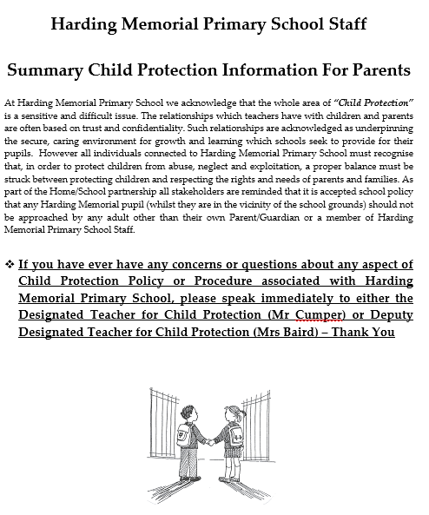

Appendix 1 at Harding Memorial Primary School = Specific Types of Abuse

Grooming of a child or young person is always abusive and/or exploitative. It often involves perpetrator(s) gaining the trust of the child or young person or, in some cases, the trust of the family, friends or community, and/or making an emotional connection with the victim in order to facilitate abuse before the abuse begins. This may involve providing money, gifts, drugs and/or alcohol or more basic needs such as food, accommodation or clothing to develop the child’s/young person’s loyalty to and dependence upon the person(s) doing the grooming. The person(s) carrying out the abuse may differ from those involved in grooming which led to it, although this is not always the case. Grooming is often associated with Child Sexual Exploitation (CSE) but can be a precursor to other forms of abuse. Grooming may occur face to face, online and/or through social media, the latter making it more difficult to detect and identify. If the staff in Harding Memorial Primary School become aware of signs that may indicate grooming they will take early action and follow the school’s child protection policies and procedures.

Child sexual exploitation (CSE) is a form of child sexual abuse. It occurs where an individual or group takes advantage of an imbalance of power to coerce, manipulate or deceive a child or young person under the age of 18 into sexual activity (a) in exchange for something the victim needs or wants, and/ or (b) for the financial advantage or increased status of the perpetrator or facilitator. The victim may have been sexually exploited even if the sexual activity appears consensual. Child sexual exploitation does not always involve physical contact; it can also occur through the use of technology. (Co-operating to Safeguard Children and Young People in NI. DHSSPS version 2.0 2017). The key factor that distinguishes cases of CSE from other forms of child sexual abuse is the concept of exchange – the fact that someone coerces or manipulates a child into engaging in sexual activity in return for something they need or desire and/or for the gain of those perpetrating or facilitating the abuse. The something received by the child or young person can include both tangible items and/or more intangible ‘rewards’ OR ‘benefits’ such as perceived affection, protection or a sense of value or belonging. Any child under the age of eighteen, male or female, can be a victim of CSE, including those who can legally consent to have sex. The abuse most frequently impacts upon those of a post-primary age and can be perpetrated by adults or peers, on an individual or group basis. CSE is a form of child abuse and, as such, any member of staff suspecting that CSE is occurring will follow the school’s child protection policy and procedures, including reporting to the appropriate agencies.

Domestic and Sexual violence and abuse can have a profoundly negative effect on a child’s emotional, psychological and social well-being. A child does not have to witness domestic violence to be adversely affected by it. Living in a violent or abusive domestic environment is harmful to children. Domestic violence and abuse is defined as ‘threatening, controlling, coercive behaviour, violence or abuse (psychological, virtual, physical, verbal, sexual, financial or emotional) inflicted on anyone (irrespective of age, ethnicity, religion, gender, identity, sexual orientation or any form of disability) by a current or former intimate partner or family member.’ Sexual Violence and Abuse is defined as ‘any behaviour (physical, psychological, verbal, virtual /online perceived to be of a sexual nature which is controlling, coercive, exploitative, harmful or unwanted that is inflicted on anyone (irrespective of age, ethnicity, religion, gender, gender identity, sexual orientation or any form of disability).’ (Stopping Domestic and Sexual Violence and Abuse in Northern Ireland A Seven Year Strategy: March 2016). If it comes to the attention of school staff that Domestic Abuse is, or may be, affecting a child this will be passed on to the Designated/Deputy Designated Teacher who has an obligation to share the information with the Social Services Gateway Team.

Female Genital Mutilation (FGM) is a form of child abuse and violence against women and girls. FGM comprises all procedures that involve partial or total removal of the external female genitalia, or other injury to the female genital organs for non-medical reasons. The procedure is also referred to as ‘cutting’, ‘female circumcision’ and ‘initiation’. The practice is medically unnecessary, extremely painful and has serious health consequences, both at the time when the mutilation is carried out and in later life. FGM is a form of child abuse and, as such, teachers have a statutory duty to report cases, including suspicion, to the appropriate agencies, through agreed established procedures set out in our school policy.

Forced Marriage A forced marriage is a marriage conducted without the valid consent of one or both parties and where duress is a factor. Duress can include physical, psychological, financial, sexual and emotional pressure. Forced marriage is a criminal offence in Northern Ireland and if in Harding Memorial Primary School we have knowledge or suspicion of a forced marriage in relation to a child or young person we will contact the PSNI immediately.

Children who display harmful sexualised behaviour
Learning about sex and sexual behaviour is a normal part of a child’s development. It will help them as they grow up, and as they start to make decisions about relationships. As a school we support children and young people, through the Personal Development element of the curriculum, to develop their understanding of relationships and sexuality and the responsibilities of healthy relationships. Teachers are often therefore in a good position to consider if behaviour is within the normal continuum or otherwise. It is important to distinguish between different sexual behaviours - these can be defined as ‘healthy’, ‘problematic’ or ‘sexually harmful’. Healthy sexual behaviour will normally have no need for intervention, however consideration may be required as to appropriateness within a school setting. Problematic sexual behaviour requires some level of intervention, depending on the activity and level of concern. For example, a one-off incident may simply require liaising with parents on setting clear direction that the behaviour is unacceptable, explaining boundaries and providing information and education. Alternatively, if the behaviour is considered to be more serious, perhaps because there are a number of aspects of concern, advice from the EA CPSS may be required. We will also take guidance from DE Circular 2016/05 to address concerns about harmful sexualised behaviour displayed by children and young people.

What is Harmful Sexualised Behaviour ?
Harmful sexualised behaviour is any behaviour of a sexual nature that takes place when:
- There is no informed consent by the victim
- The perpetrator uses threat (verbal, physical or emotional) to coerce, threaten or intimidate the victim
- Harmful sexualised behaviour can include: Using age inappropriate sexually explicit words and phrases
- Inappropriate touching
- Using sexual violence or threats
- Sexual behaviour between children is also considered harmful if one of the children is much older - particularly if there is more than two years’ difference in age or if one of the children is pre-pubescent and the other is not
- However, a younger child can abuse an older child, particularly if they have power over them - for example, if the older child is disabled.

Sexually harmful behaviour is primarily a child protection concern. There may remain issues to be addressed through the schools positive behaviour policy but it is important to always apply principles that remain child centred. Harmful sexualised behaviour will always require intervention and in our school we will refer to our child protection policy and, seek the support that is available from the CPSS.

E Safety/Internet Abuse
Online safety means acting and staying safe when using digital technologies. It is wider than simply internet technology and includes electronic communication via text messages, social environments and apps, and using games consoles through any digital device. In all cases, in schools and elsewhere, it is a paramount concern. In January 2014, the SBNI published its report ‘An exploration of e-safety messages to young people, parents and practitioners in Northern Ireland’ which identified the associated risks around online safety under four categories:

- Content risks: the child or young person is exposed to harmful material.
- Contact risks: the child or young person participates in adult initiated online activity.
- Conduct risks: the child or young person is a perpetrator or victim in peer-to-peer exchange.
- Commercial risks: the child or young person is exposed to inappropriate commercial advertising, marketing schemes or hidden costs.

We in Harding Memorial Primary School have a responsibility to ensure that there is a reduced risk of pupils accessing harmful and inappropriate digital content and will be energetic in teaching pupils how to act responsibly and keep themselves safe. As a result, all our pupils should have a clear understanding of online safety issues and, individually, be able to demonstrate what a positive digital footprint might look like. The school’s actions and governance of online safety are reflected clearly in our safeguarding arrangements. Safeguarding and promoting pupils’ welfare around digital technology is the responsibility of everyone who comes into contact with the pupils in the school or on school-organised activities.

Sexting is the sending or posting of sexually suggestive images, including nude or semi-nude photographs, via mobile or over the internet. There are two aspects to Sexting: Sexting between individuals in a relationship schools should look at this individually. Whilst their procedures should be the same as below they may want to include something specific here re what their preventative curriculum approach will be. Pupils need to be aware that it is illegal, under the Sexual Offences (NI) Order 2008, to take, possess or share ‘indecent images’ of anyone under 18 even if they are the person in the picture (or even if they are aged 16+ and in a consensual relationship) and in these cases we will contact local police on 101 for advice and guidance. We may also seek advice from the EA Child Protection Support Service.

Please be aware that, while offences may technically have been committed by the child/children involved, the matter will be dealt with sensitively and considering all of the circumstances and it is not necessarily the case that they will end up with a criminal record. It is important that particular care is taken in dealing with any such cases. Adopting scare tactics may discourage a young person from seeking help if they feel entrapped by the misuse of a sexual image.

Sharing an inappropriate image with an intent to cause distress
If a pupil has been affected by inappropriate images or links on the internet it is important that it is not forwarded to anyone else. Schools are not required to investigate incidents. It is an offence under the Criminal Justice and Courts Act 2015 to share an inappropriate image of another person without the individuals consent. www.legislation.gov.uk/ukpga/2015/2/section/33/enacted). If a young person has shared an inappropriate image of themselves that is now being shared further whether or not it is intended to cause distress, the child protection procedures of Harding Memorial Primary School will be followed.

Appendix 1 = Continued Signs and symptoms of abuse Information for Schools

Please find attached a link to signs and symptoms from the SBNI Regional Core Policies & Procedures guidance. Sample information sheets have been printed off below for information.
https://proceduresonline.com/trixcms/media/1248/signs-and-symptoms-of-child-abuse-and-neglect.pdf

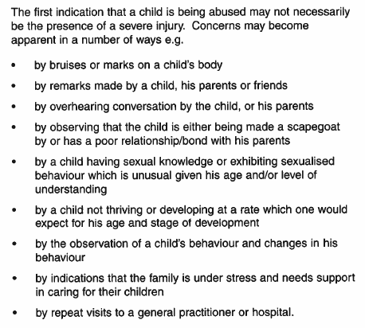

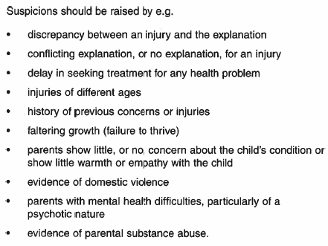

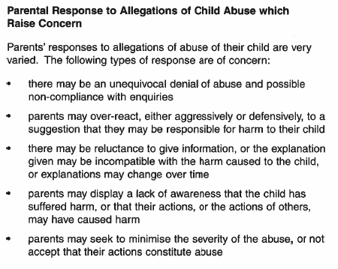
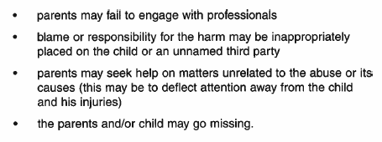

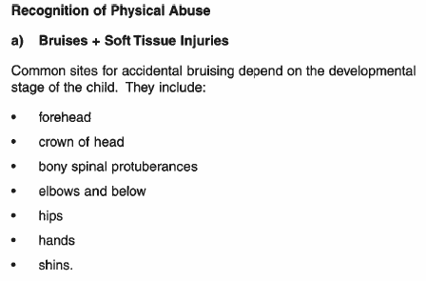

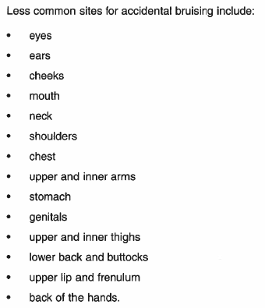

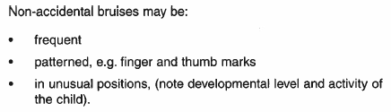

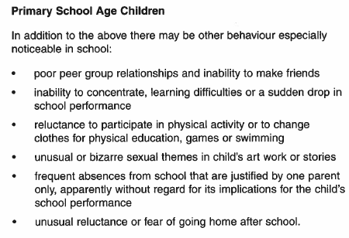
Appendix 2 = Children with Increased Vulnerabilities

Children with a disability
Children and young people with disabilities (i.e. any child or young person who has a physical, sensory or learning impairment or a significant health condition) may be more vulnerable to abuse and those working with children with disabilities should be aware of any vulnerability factors associated with risk of harm, and any emerging child protection issues. Staff must be aware that communication difficulties can be hidden or overlooked making disclosure particularly difficult. Staff and volunteers working with children with disabilities will receive training to enable them to identify and refer concerns early in order to allow preventative action to be taken.

Children with limited fluency in English
As with children with a special educational need, children who are not fluent in English should be given the chance to express themselves to a member of staff or other professional with appropriate language/communication skills, especially where there are concerns that abuse may have occurred.
Designated Teachers should work with their SEN co-ordinators along with school staff with responsibility for newcomer pupils, seeking advice from the EA’s Inclusion and Diversity Service to identify and respond to any particular communication needs that a child may have. All schools should try to create an atmosphere in which pupils with special educational needs which involve communication difficulties, or pupils for whom English is not their first language, feel confident to discuss these issues or other matters that may be worrying them.

Pre-school provision - Many of the issues in the preceding paragraphs will be relevant to our young children who may have limited communication skills. In addition to the above, staff will follow our Intimate Care policy and procedures in consultation with the child’s Parent/Guardians

Looked After Children
In consultation with other agencies and professionals, a Health and Social Care Trust may determine that a child or young person’s welfare cannot be safeguarded if they remain at home. In these circumstances, a child may be accommodated through a voluntary arrangement with the persons with parental responsibility for the child or the HSCT may make an application to the Court for a Care Order to place the child or young person in an alternative placement provided by the Trust. The HSCT will then make arrangements for the child to be looked after, either permanently or temporarily. It is important that the views of children, young people and their parents and/or others with parental responsibility for the looked child are taken into account when decisions are made.
A member of school staff will attend LAC meetings and will provide a written report. Where necessary, school support will be put in place for the child/young person. Information will be shared with relevant staff on a need to know basis.

Children / Young People who go missing
Children and young people who go missing come from all backgrounds and communities and are known to be at greater risk of harm. This includes risks of being sexually abused or exploited although children and young people may also become homeless or a victim or perpetrator of crime. Those who go missing from their family home may have no involvement with services as not all children and young people who run away or go missing from their family home have underlying issues within the family, or are reported to the police as missing. The patterns of going missing may include overnight absences or those who have infrequent unauthorised absences of short time duration. When a child or young person returns, having been missing for a period, we should be alert to the possibility that they may have been harmed and to any behaviours or relationships or other indicators that children and young people may have been abused. School staff will work in partnership with those who look after the child or young person who goes missing and, if appropriate, will complete a risk assessment. Current school policies will apply e.g. attendance, safeguarding, relationships and sexuality education.

Separated, unaccompanied and trafficked children and young people.
Separated children and young people are those who have been separated from their parents, or from their previous legal or customary primary caregiver. Unaccompanied children and young people are those seeking asylum without the presence of a legal guardian. Consideration must be given to the fact that separated or unaccompanied children may be a victim of human trafficking. Child Trafficking is the recruitment, transportation, transfer, harbouring or receipt of a child or young person, whether by force or not, by a third person or group, for the purpose of different types of exploitation. If we become aware of a child or young person who may be separated, unaccompanied or a victim of human trafficking we in Harding Memorial Primary School will immediately follow our School Safeguarding and Child Protection Procedures

Children of parents with additional support needs
Children and young people can be affected by the disability of those caring for them. Parents, carers or siblings with disabilities may have additional support needs which impact on the safety and wellbeing of children and young people in the family, possibly affecting their education or physical and emotional development. It is important that any action school staff take to safeguard children and young people at risk of harm in these circumstances encompasses joint working between specialist disability and children’s social workers and other professionals and agencies involved in providing services to adult family members. This will assist us in ensuring the welfare of the children and young people in the family is promoted and they are safeguarded as effectively as possible. Where it is known or suspected that parents or carers have impaired ability to care for a child, the safeguarding team will give consideration to the need for a child protection response in addition to the provision of family support and intervention.

Gender identity issues and sexual orientation
Young people from the LGBTQ community may face particular difficulties which could make them more vulnerable to harm. These difficulties could range from intolerance and homophobic bullying from others to difficulties for the young person themselves in exploring and understanding their sexuality. At such times young people may be more vulnerable to predatory advances from adults seeking to exploit or abuse them. This could impede a young person’s ability or willingness to raise concerns if they feel they are at risk or leave young people exposed to contact with people who would exploit them. As a staff working with young people from the LGBT community we will support them to appropriately access information and support on healthy relationships and to report any concerns or risks of abuse or exploitation.

Work experience, school trips, educational visits & residential settings
Our duty to safeguard and promote the welfare of children and young people also includes periods when they are in our care outside of the school setting. We will follow Department of Education guidance on Educational Visits, School Trips, Residential Trips and work experience in Harding Memorial Primary School to ensure our current safeguarding policies are adhered to and that appropriate staffing levels are in place and staff are appropriately vetted

Children/Young People’s Behaviours

Peer Abuse
Children and young people may be at risk of physical, sexual and emotional bullying and abuse by their peers. Such abuse should always be taken as seriously as abuse perpetrated by an adult. Where a child or young person has been harmed by another, all school staff should be aware of their responsibilities in relation to both children and young people who perpetrate the abuse as well as those who are victims of it and, where necessary, should contribute to an inter-disciplinary and multi-agency response.

Self-Harm
Self-harm encompasses a wide range of behaviours and things that people do to themselves in a deliberate and usually hidden way, which are damaging. It may indicate a temporary period of emotional pain or distress, or deeper mental health issues which may result in the development of a progressive pattern of worsening self-harm that may ultimately result in death by misadventure or suicide. Self-harm may involve abuse of substances such as alcohol or drugs, including both illegal and/or prescribed drugs. Self-harming behaviours may indicate that a child or young person has suffered abuse; however this is not always the case. School staff should share concerns about a child or young person who is self-harming with a member of the safeguarding team who will seek advice from appropriately qualified and experienced professionals including those in the non-statutory sector to make informed assessments of risk in relation to self-harming behaviours.

Suicidal Ideation
All Staff in Harding Memorial Primary School must act without delay if they have concerns about a child or young person who presents as being suicidal as it is important that children and young people who communicate thoughts of suicide or engage in para-suicidal behaviours are seen urgently by an appropriately qualified and experienced professional, including those in the non-statutory sector, to ensure they are taken seriously, treated with empathy, kindness and understanding and informed assessments of risk and needs can be completed as a matter of priority.

Attendance at Child Protection Case Conferences and Core Group Meetings

The Designated Teacher (Mr Cumper) or Deputy Designated Teacher (Mrs Baird) may be invited to attend an initial and review Child Protection Case Conferences and/or core group meetings convened by the Health & Social Care Trust. They will provide a written report which will be compiled following consultation with relevant staff. Feedback will be given to staff under the “need to know” principle on a case-by-case basis. Children whose names are on the Child Protection register will be monitored and supported in accordance with the child protection plan.

“The welfare of children and young people must be promoted and they must be given every opportunity to develop to their full potential, free from harm through abuse, exploitation and neglect.”
(Co-operating to Safeguard Children and Young People in Northern Ireland – March 2016)

Appendix 3 = If a Parent/Guardian has a potential Child Protection concern:
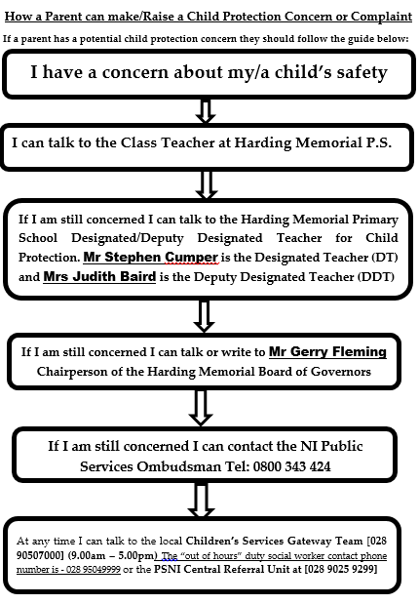
Appendix 4 = Procedure where Harding Memorial P.S. has concerns, or has been given information, about possible abuse by someone other than a member of staff

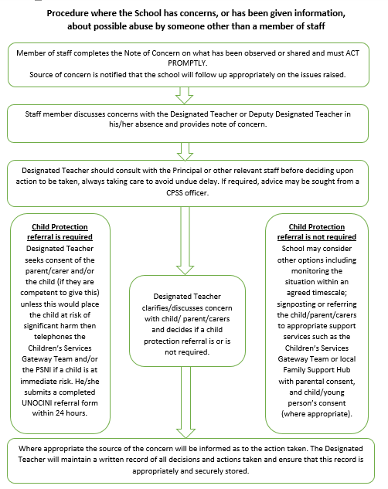

Appendix 5 = Dealing with Allegations of Abuse Against A Member of Staff

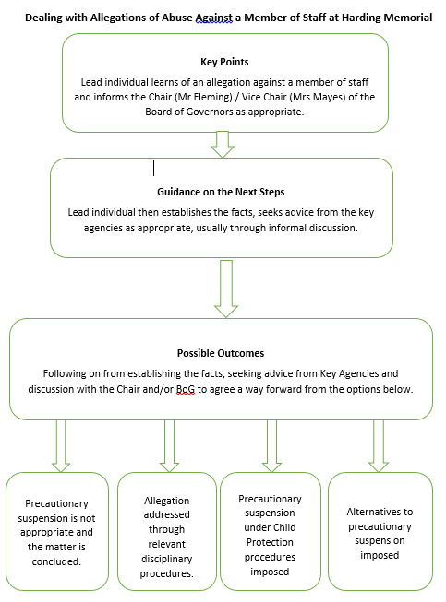
Appendix 6 = Initial Note of Concern – Part 1
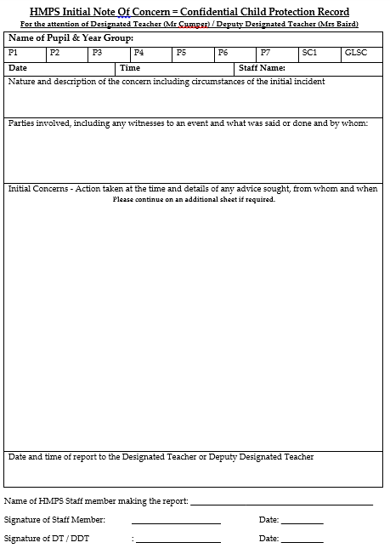

Appendix 6 = Initial Note of Concern – Part 2

Co-Operating to Safeguard Children and Young People in Northern Ireland (August 2017) https://www.health-ni.gov.uk/publications/co-operating-safeguard-children-and-young-people-northern-ireland

